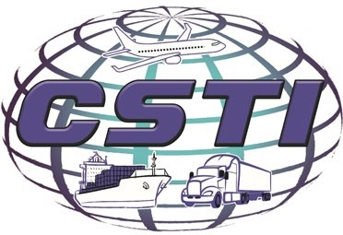
CSTI

PO Box 1074
Platte City, MO 64079

P: 816.7
82.6500

F: 816.873.5833
E:
ops@cstikc.com

W: www.cstikc.com

Customs Brokerage
Our friendly CSTI staff has the expertise, experience, and technology we need to take care of every aspect of Customhouse brokerage for you.
- Our Customs broker service will keep your financial liability to a minimum because they are up-to-date on duties, informed compliance, and Customs regulations, including USDA and FDA requirements.
- Our Automated Commercial Environment Secure Data Portal (ACE Portal) and Automated Broker Interface with the Customs and Border Protection system give you faster, less complicated service as well as the ability to track your shipments in real time.
- When your shipment is properly manifested on a conveyance and is not subject to quota, we can request Customs pre-filing five days before your shipment arrives at an ocean or inland port.
- As soon as wheels are up, we can pre-file your direct airfreight shipments.

Courtesy Reminders
Enforcement of Import Security Filing (ISF) regulations went into effect January 26, 2010. Late or improper filing can result in penalties ranging from $5,000 to $10,000 per violation. Please allow CSTI to help you with ISF compliance by contacting us with any questions that you may have.
We are in Phase IV of the Lacey Act. A Plant Protection and Quarantine (PPQ) 505 Declaration is required to obtain release of the Harmonized Tariff Schedule (HTS) numbers listed in Phase I, II and III of the Lacey Act. Providing false or misleading information to the U. S. Government will result in penalties in the amount of $10,000 for values under $350 or $20,000 for values over $350 and/or civil or criminal actions.
For Customhouse brokerage services, call CSTI

